Hospital Smart Queue System Technical Brief
This document outlines the strategic problem statement, quality assurance protocols, and operational criteria for the Hospital Smart Queue System project.

1. Problem Statement
Healthcare facilities often face inefficiencies from manual queue management and outdated workflows. Fragmented booking systems cause long wait times and limited visibility, while administrators struggle to track staff and attendance accurately.

2. Functional & Non-Functional Requirements

2.1 Functional Requirements
- Authentication: Secure user login and identity verification using JWT.
- Administrative: Management of staff credentials, institutional records, and system analytics.
- Scheduling: Atomic booking logic to create, update, and manage patient appointments without conflicts.
- Real-time Communication: Instant synchronization of dashboard states across all user roles via Socket.IO.

2.2 Non-Functional Requirements
- Performance: Target uptime >= 99%, average response time <= 2s, and low-latency real-time updates.
- Security: Implementation of JWT session tokens, password hashing, and Role-Based Access Control (RBAC).
- Usability: Clinical-grade dark UI interface with high-contrast accessibility standards.
- Reliability: Validation through Jest unit testing and comprehensive End-to-End (E2E) journey testing.

Patients suffer from unpredictable schedules, and staff deal with rigid systems that fail to handle emergencies or walk-ins, causing conflicts and reduced care quality.

The Hospital Smart Queue System replaces manual methods with an automated, role-based architecture. Using Socket.IO for real-time updates and centralized scheduling, the system streamlines appointments and provides analytical oversight to optimize performance.

3. Authentication Module: Jest Test Case Matrix
The following test cases ensure the reliability of the JSON Web Token (JWT) based authentication protocol.

Test ID | Description | Input Parameters | Expected Outcome
AUTH-01 | Successful User Login | Valid Email + Valid Password | 200 OK; Return JWT and user role data.
AUTH-02 | Failed Login: Incorrect Password | Valid Email + Invalid Password | 401 Unauthorized; Error message: "Invalid credentials."
AUTH-03 | Failed Login: Non-existent User | Invalid Email + Any Password | 404 Not Found; Error message: "User does not exist."
AUTH-04 | Token Expiration Verification | Expired JWT Token | 401 Unauthorized; Trigger redirect to Sign-In page.
AUTH-05 | Invalid JWT Signature | Manually Altered JWT Token | 403 Forbidden; Token validation fails.
AUTH-06 | Missing Required Fields | Empty Email or Password field | 400 Bad Request; Validation error for required fields.
AUTH-07 | Role-Based Access: Admin | Valid Admin JWT | Access granted to Staff Management and Analytics.
AUTH-08 | Role-Based Access: Unauthorized | Patient JWT accessing Admin API | 403 Forbidden; Access denied based on role.
AUTH-09 | Password Hashing Verification | New User Registration | Password stored as hash; original text not visible in DB.
AUTH-10 | Concurrent Session Handling | Multiple login requests | System maintains session integrity for active token.

4. Use Case Diagram & Descriptions
The following use case specifications formalize the system interactions for each primary actor.
Use Case 1: Manage Staff Credentials
Primary Actor: Admin
Preconditions: Admin is authenticated with valid RBAC permissions.
Main Flow:
- Admin navigates to the Staff Management dashboard.
- Admin selects a staff record to modify or creates a new one.
- Admin updates the email, password, or role.
- System validates and persists changes to MongoDB.
Postconditions: Staff credentials are updated in the database.
Use Case 2: Update Consultation Status
Primary Actor: Doctor
Preconditions: Doctor is logged in and viewing their daily schedule.
Main Flow:
- Doctor selects an active appointment from the timeline.
- Doctor marks the appointment as "Completed".
- System updates the appointment status and emits a Socket.IO event.
Postconditions: Appointment status reflects completion across all dashboards.

Use Case 3: Create Patient Appointment
Primary Actor: Receptionist
Preconditions: Receptionist is on the dashboard with patient details ready.
Main Flow:
- Receptionist opens the appointment creation modal.
- Receptionist inputs patient ID, doctor, and time slot.
- System performs an atomic availability check.
- System saves the booking and notifies the patient/doctor.
Postconditions: A new appointment record is successfully created.
Use Case 4: Self-Schedule Appointment
Primary Actor: Patient
Preconditions: Patient is logged into the mobile/web interface.
Main Flow:
- Patient browses departments and selects a doctor.
- Patient chooses an available time slot (excluding blockTimes).
- Patient confirms the selection.
- System validates and emits a real-time notification to the staff.
Postconditions: Appointment is booked and appears in patient history.

5. API Documentation: Create Appointment Endpoint
This endpoint facilitates the core scheduling logic managed by the Receptionist role.

POST /api/appointments
Creates a new patient appointment in the system.

Request Body:{

"patientId": "String",

"doctorId": "String",

"departmentId": "String",

"appointmentDate": "Date",

"timeSlot": "String",

"type": "Walk-in" | "Phone"

}

Status Codes:

- 201 Created: Appointment successfully scheduled and saved to MongoDB.
- 400 Bad Request: Missing mandatory fields or invalid date format.
- 409 Conflict: The selected doctor is unavailable or the slot is already booked.
- 401 Unauthorized: Missing or invalid JWT session token.

ER Diagram (Entity-Relationship Diagram) showcasing database structure and physical schemas:
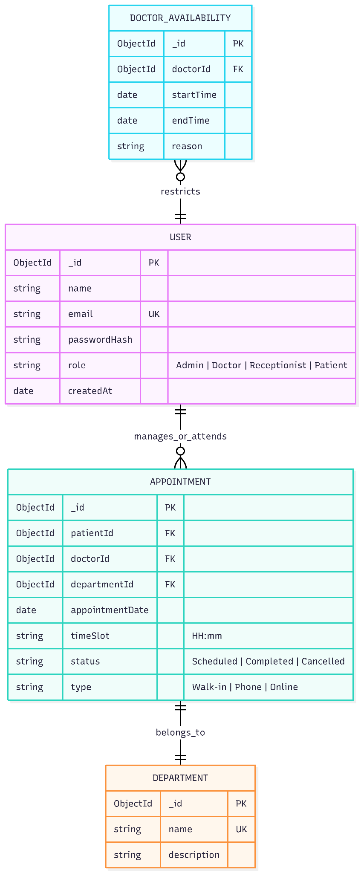
Class Diagram defining the structure of the system (classes, attributes, relationships):
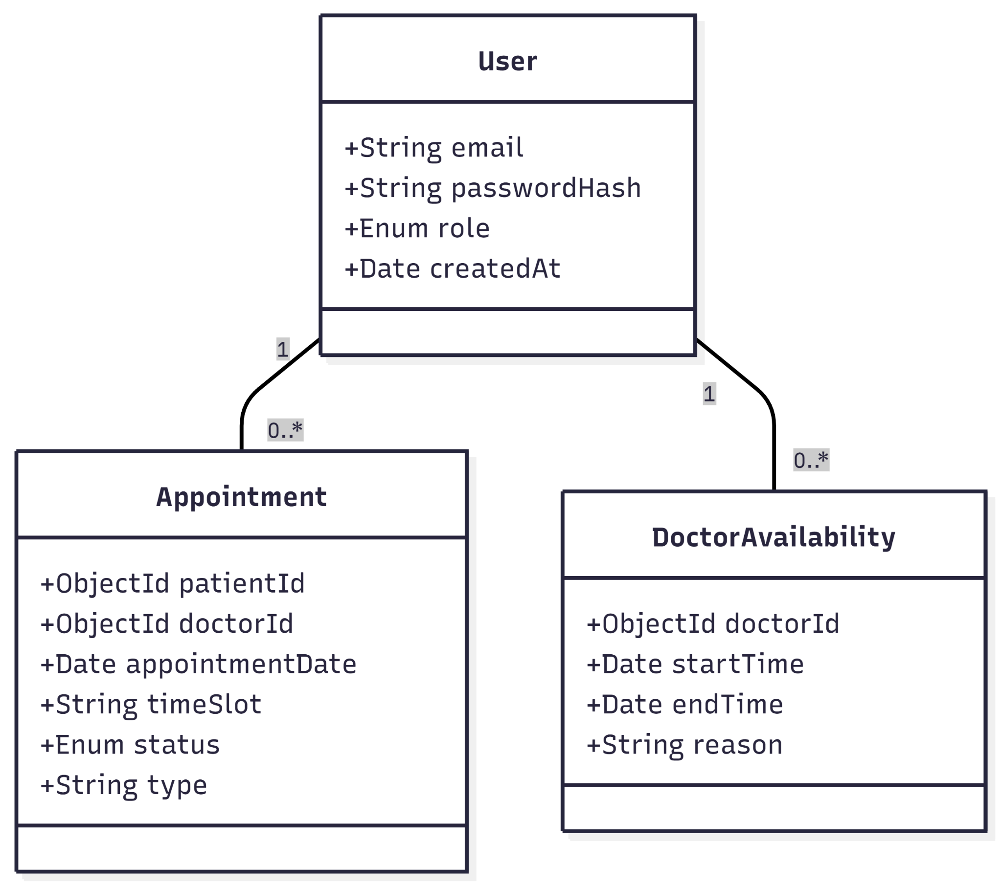
State Diagram representing the different states of an appointment object:
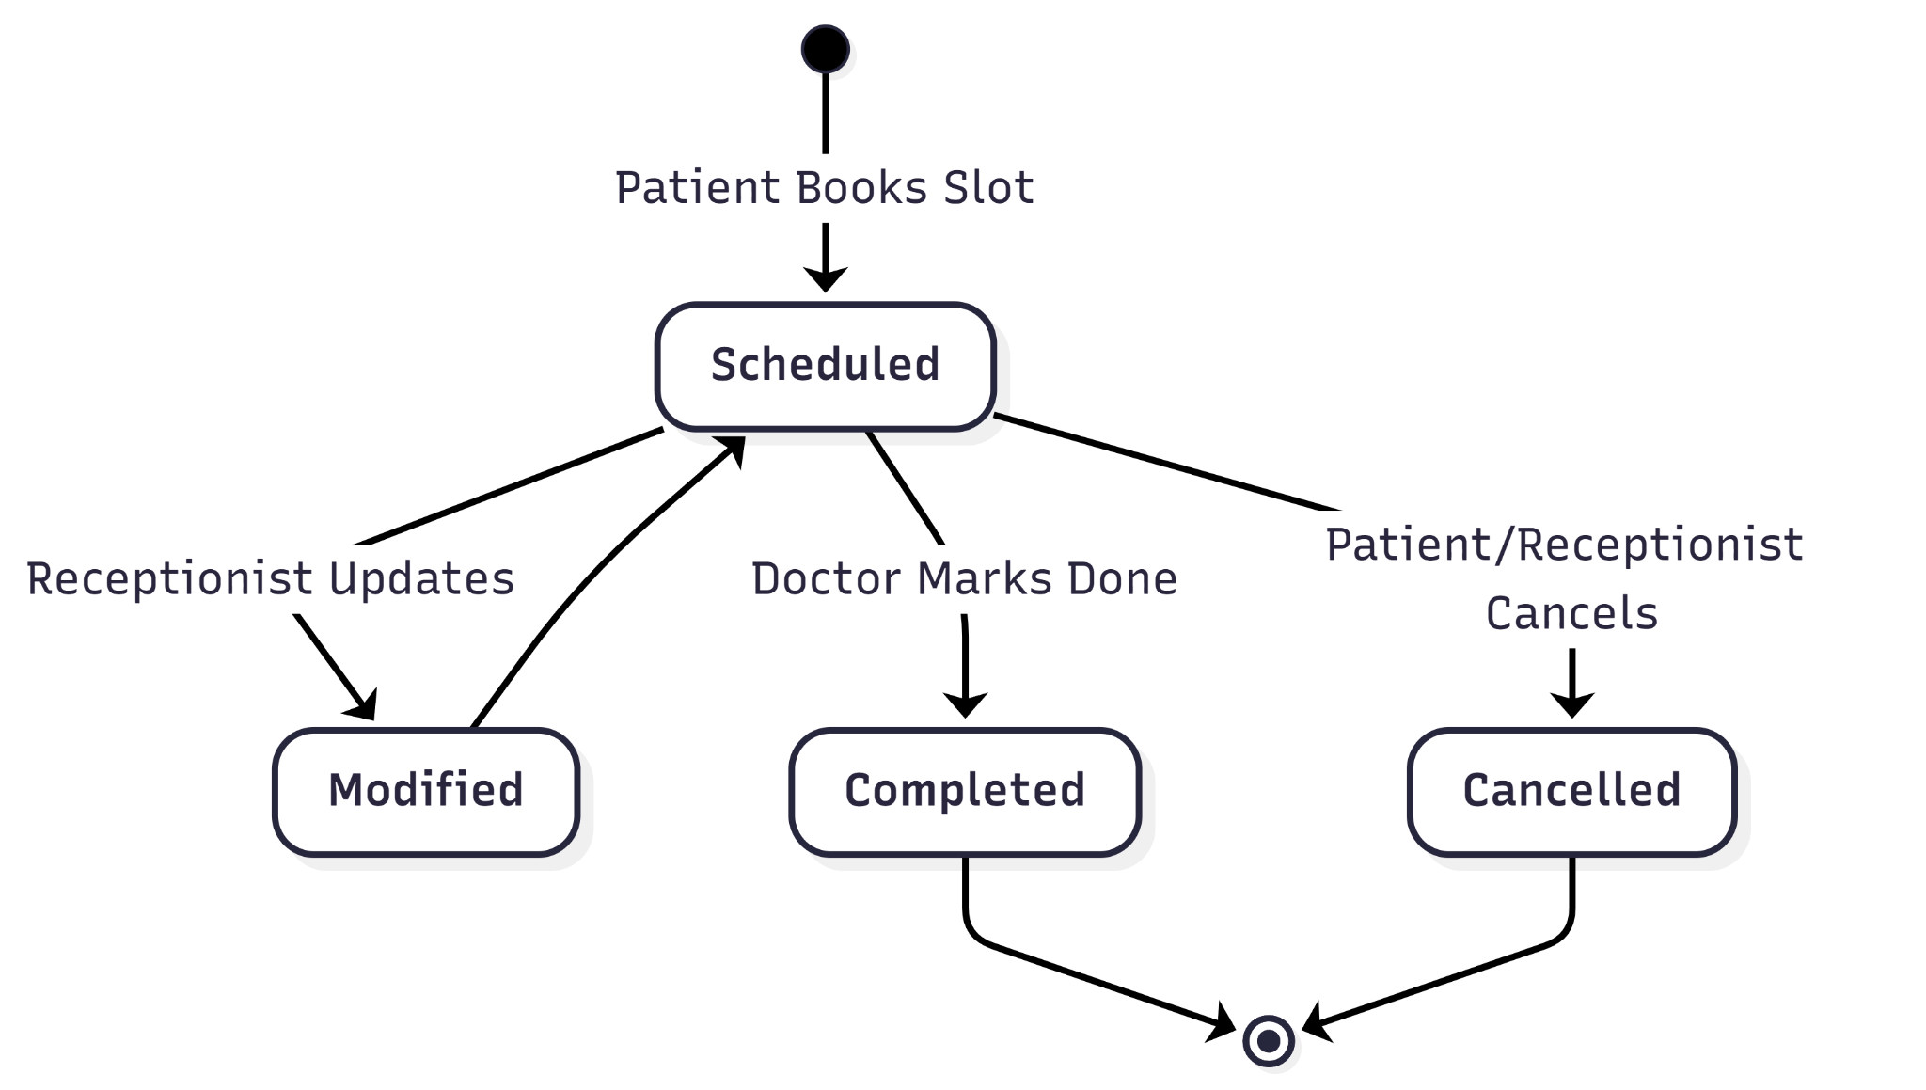

6. Data Dictionary

Field Name | Data Type | Constraints | Description
Users Collection
_id | ObjectId (MongoDB) | Required, Unique, Primary Key | System-generated unique identifier for the user account.
email | String | Required, Unique | User's primary login credential, required for JWT session management.
password | String | Required, Hashed | User's password, must be stored as a secure hash.
fullName | String | Required | The full name of the staff member or patient.
role | String | Required, Enum: Admin, Receptionist, Doctor, Patient | Defines access privileges for role-based access control.
blockTime | Array of Date/Time Ranges | Doctor Role Only | A list of time intervals during which the doctor is unavailable for bookings.
Appointments Collection
_id | ObjectId (MongoDB) | Required, Unique, Primary Key | System-generated unique identifier for the appointment record.
patientId | ObjectId | Required, Foreign Key to Users `_id` | The ID of the patient associated with the booking.
doctorId | ObjectId | Required, Foreign Key to Users `_id` | The ID of the doctor assigned to conduct the consultation.
departmentId | ObjectId | Required, Foreign Key to Departments `_id` | The department where the appointment is scheduled.
appointmentDate | Date | Required | The calendar date of the scheduled appointment.
timeSlot | String | Required, Unique (in combination with `doctorId` and `appointmentDate`) | The specific time slot; server-side validation is required to prevent double bookings.
type | String | Required, Enum: Walk-in, Phone, Online | Indicates how the appointment was created.
status | String | Required, Default: Booked, Enum: Booked, Completed, Canceled | The current status of the appointment, used for queue management and analytics.
Departments Collection
_id | ObjectId (MongoDB) | Required, Unique, Primary Key | System-generated unique identifier for the department.
name | String | Required, Unique | The official name of the hospital department.
description | String | Optional | A brief description of the services offered by the department.

7. Data Flow & System Behavior
The Scheduling Module maintains integrity through server-side logic. To prevent double-booking, the POST /api/appointments endpoint triggers an atomic MongoDB check. This validates that the doctorId, timeSlot, and appointmentDate combination is available and does not conflict with doctor-defined blockTime intervals. Conflicts result in a 409 Conflict status.

Upon a successful database write, the Real-time Communication Module uses Socket.IO to synchronize dashboards across all roles. The server emits events for any booking status change—such as receptionist modifications or doctor completions—ensuring live, low-latency updates for Patients and Doctors.

Data Flow Diagram (DFD) showing context-level data movement:
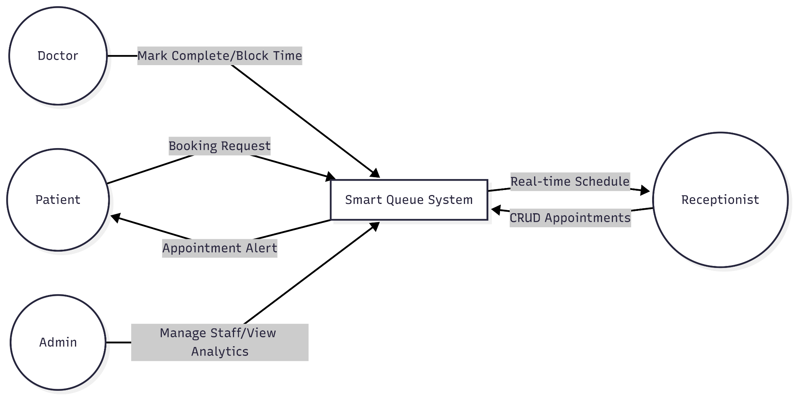
Sequence Diagram representing the process flow of appointment creation:
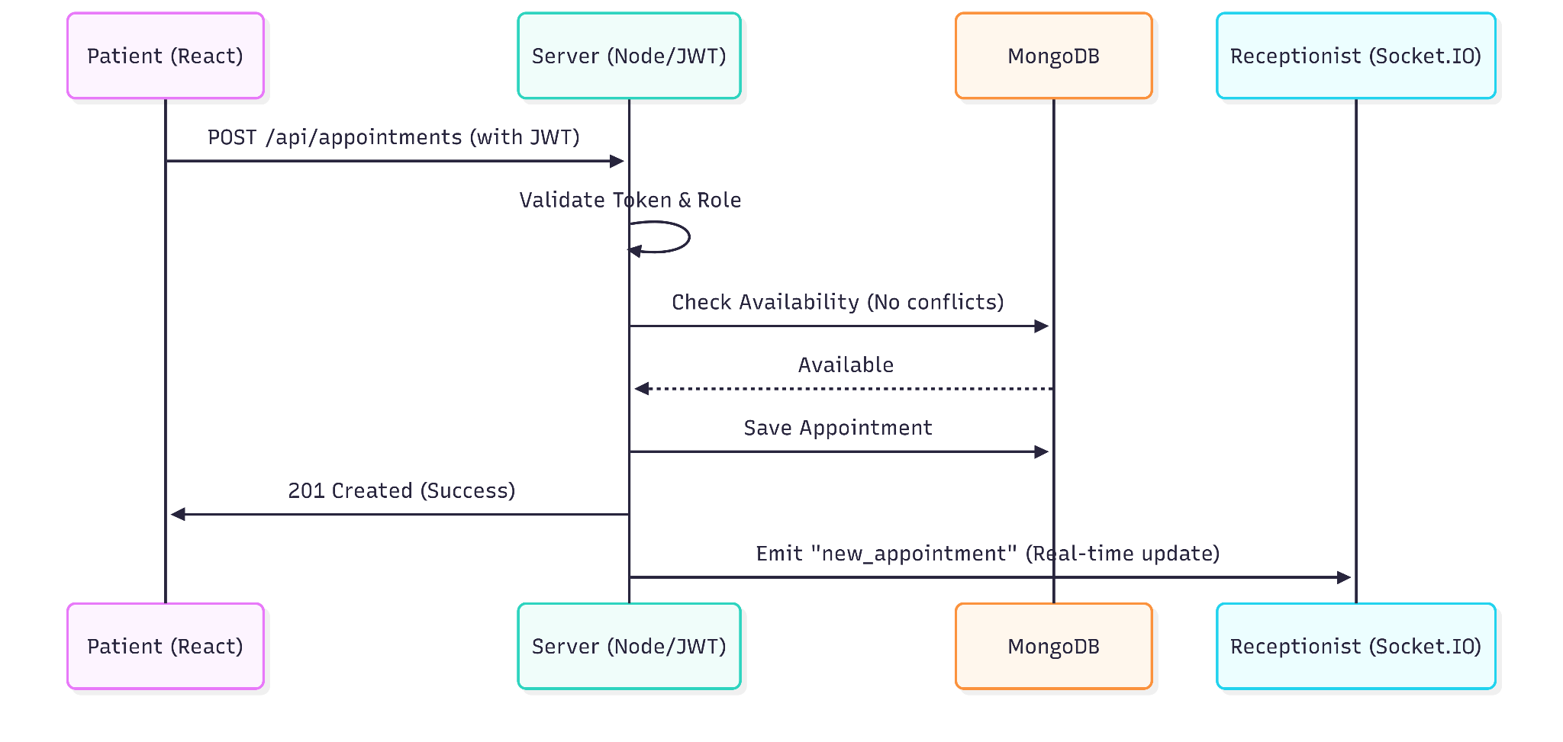
Activity Diagram visualizing the workflow of the availability check process:
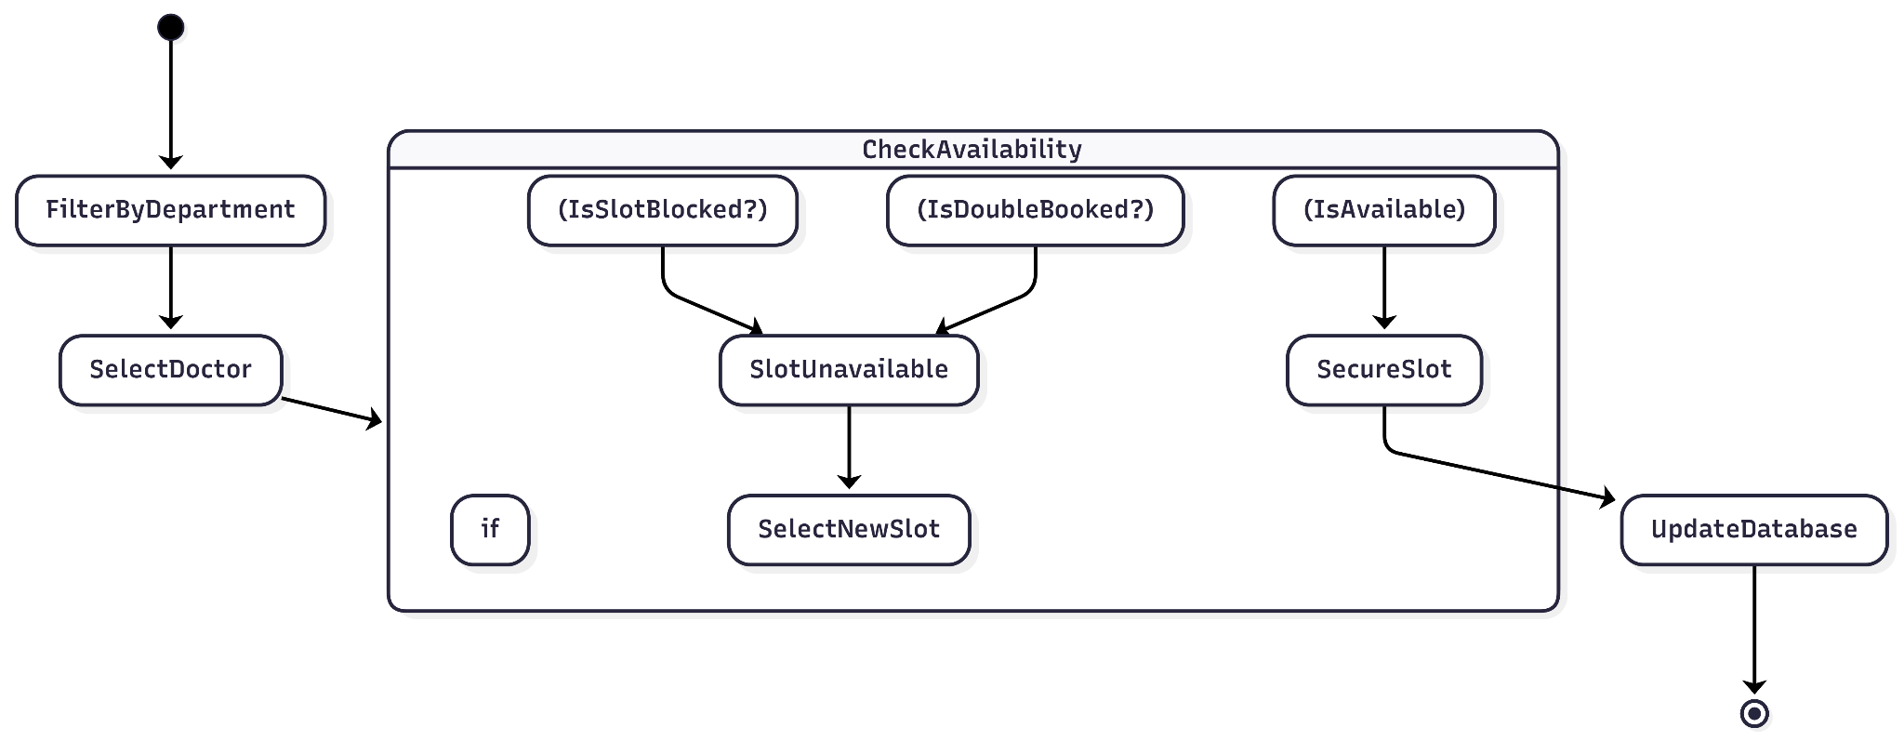

8. Design and User Flow Specifications

8.1 Design System & Style Guidelines
Incorporate this section to define the visual language of the React.js and Tailwind CSS implementation.
- Color Palette (Clinical Precision):
  - Primary (#06141B): Deep Navy for background and primary navigation.
  - Secondary (#4A5C6A): Slate Grey for cards and secondary UI elements.
  - Tertiary (#9BA8AB): Muted Blue for labels and borders.
  - Neutral (#777777): Medium Grey for disabled states and metadata.
- Typography:
  - Font Family: Inter (Sans-serif) across all roles to maintain a clean, professional look.
  - Hierarchy: Large Headline for dashboard titles, medium Body for list items, and small Labels for metadata/tags.
- Design Rationale: The dark interface minimizes glare in clinical environments, while the high-contrast accent colors (like the red delete icon) provide clear feedback for critical actions.

8.1.1 Wireframes & Mockups
High-fidelity wireframes and visual mockups for the core user interfaces—specifically the Admin, Doctor, Receptionist, and Patient dashboards—have been designed using Figma to ensure usability and visual consistency with the defined design system.

8.2 User Dashboard Layouts
Each role requires a specific layout structure based on the functional needs defined in the System Requirements Specification.
Dashboard | Core Layout Components | Primary Interaction
Admin | Sidebar Navigation, Analytics Grid (Chart.js), Staff List Table. | Managing institutional credentials and monitoring attendance rates.
Doctor | Daily Schedule Timeline, "Mark Complete" Toggle, "Block Time" Modal. | Updating consultation statuses and dictating temporal availability.
Receptionist | Global Queue View, Search/Filter Bar, Appointment CRUD Modals. | Creating, modifying, or cancelling patient appointments in real-time.
Patient | Department Selection Cards, Doctor Filter List, "My Appointments" History. | Self-scheduling appointments and receiving real-time scheduling alerts.

8.3 User Journey: Appointment Booking
- Entry: Patient logs in via the Authentication Module (JWT).
- Selection: Patient browses Department cards and selects a specialty.
- Validation: Patient selects a Doctor; the system cross-references the DoctorAvailability collection to hide "Block Time" intervals.
- Confirmation: Patient selects a slot; the Socket.IO module pushes a live notification to the Receptionist and Doctor dashboards.

9. System Deployment & Integration

9.1 Technology Stack & Component Architecture
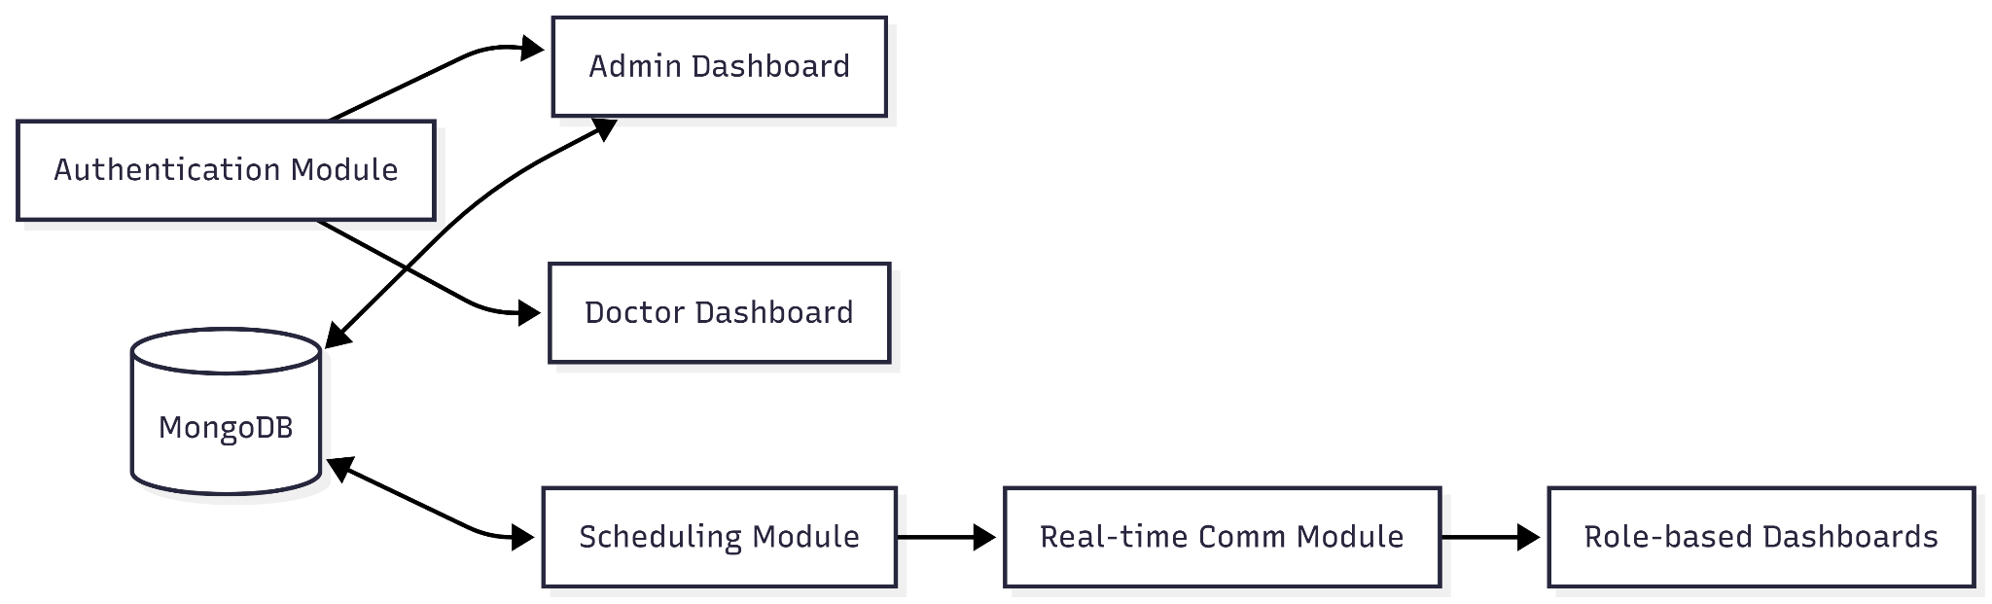
Figure 5.1: Component Relationship Diagram

Technology Stack Integration: The system utilizes the MERN stack, with JWT for secure session persistence and Socket.IO for event-driven dashboard updates.

9.2 Testing & Validation Plan
Testing Strategy: Beyond the Jest unit tests defined in the matrix, the system will undergo End-to-End (E2E) testing to simulate a full user journey (e.g., Admin creates Doctor → Patient books → Doctor completes).

9.3 Deployment Strategy & Hosting
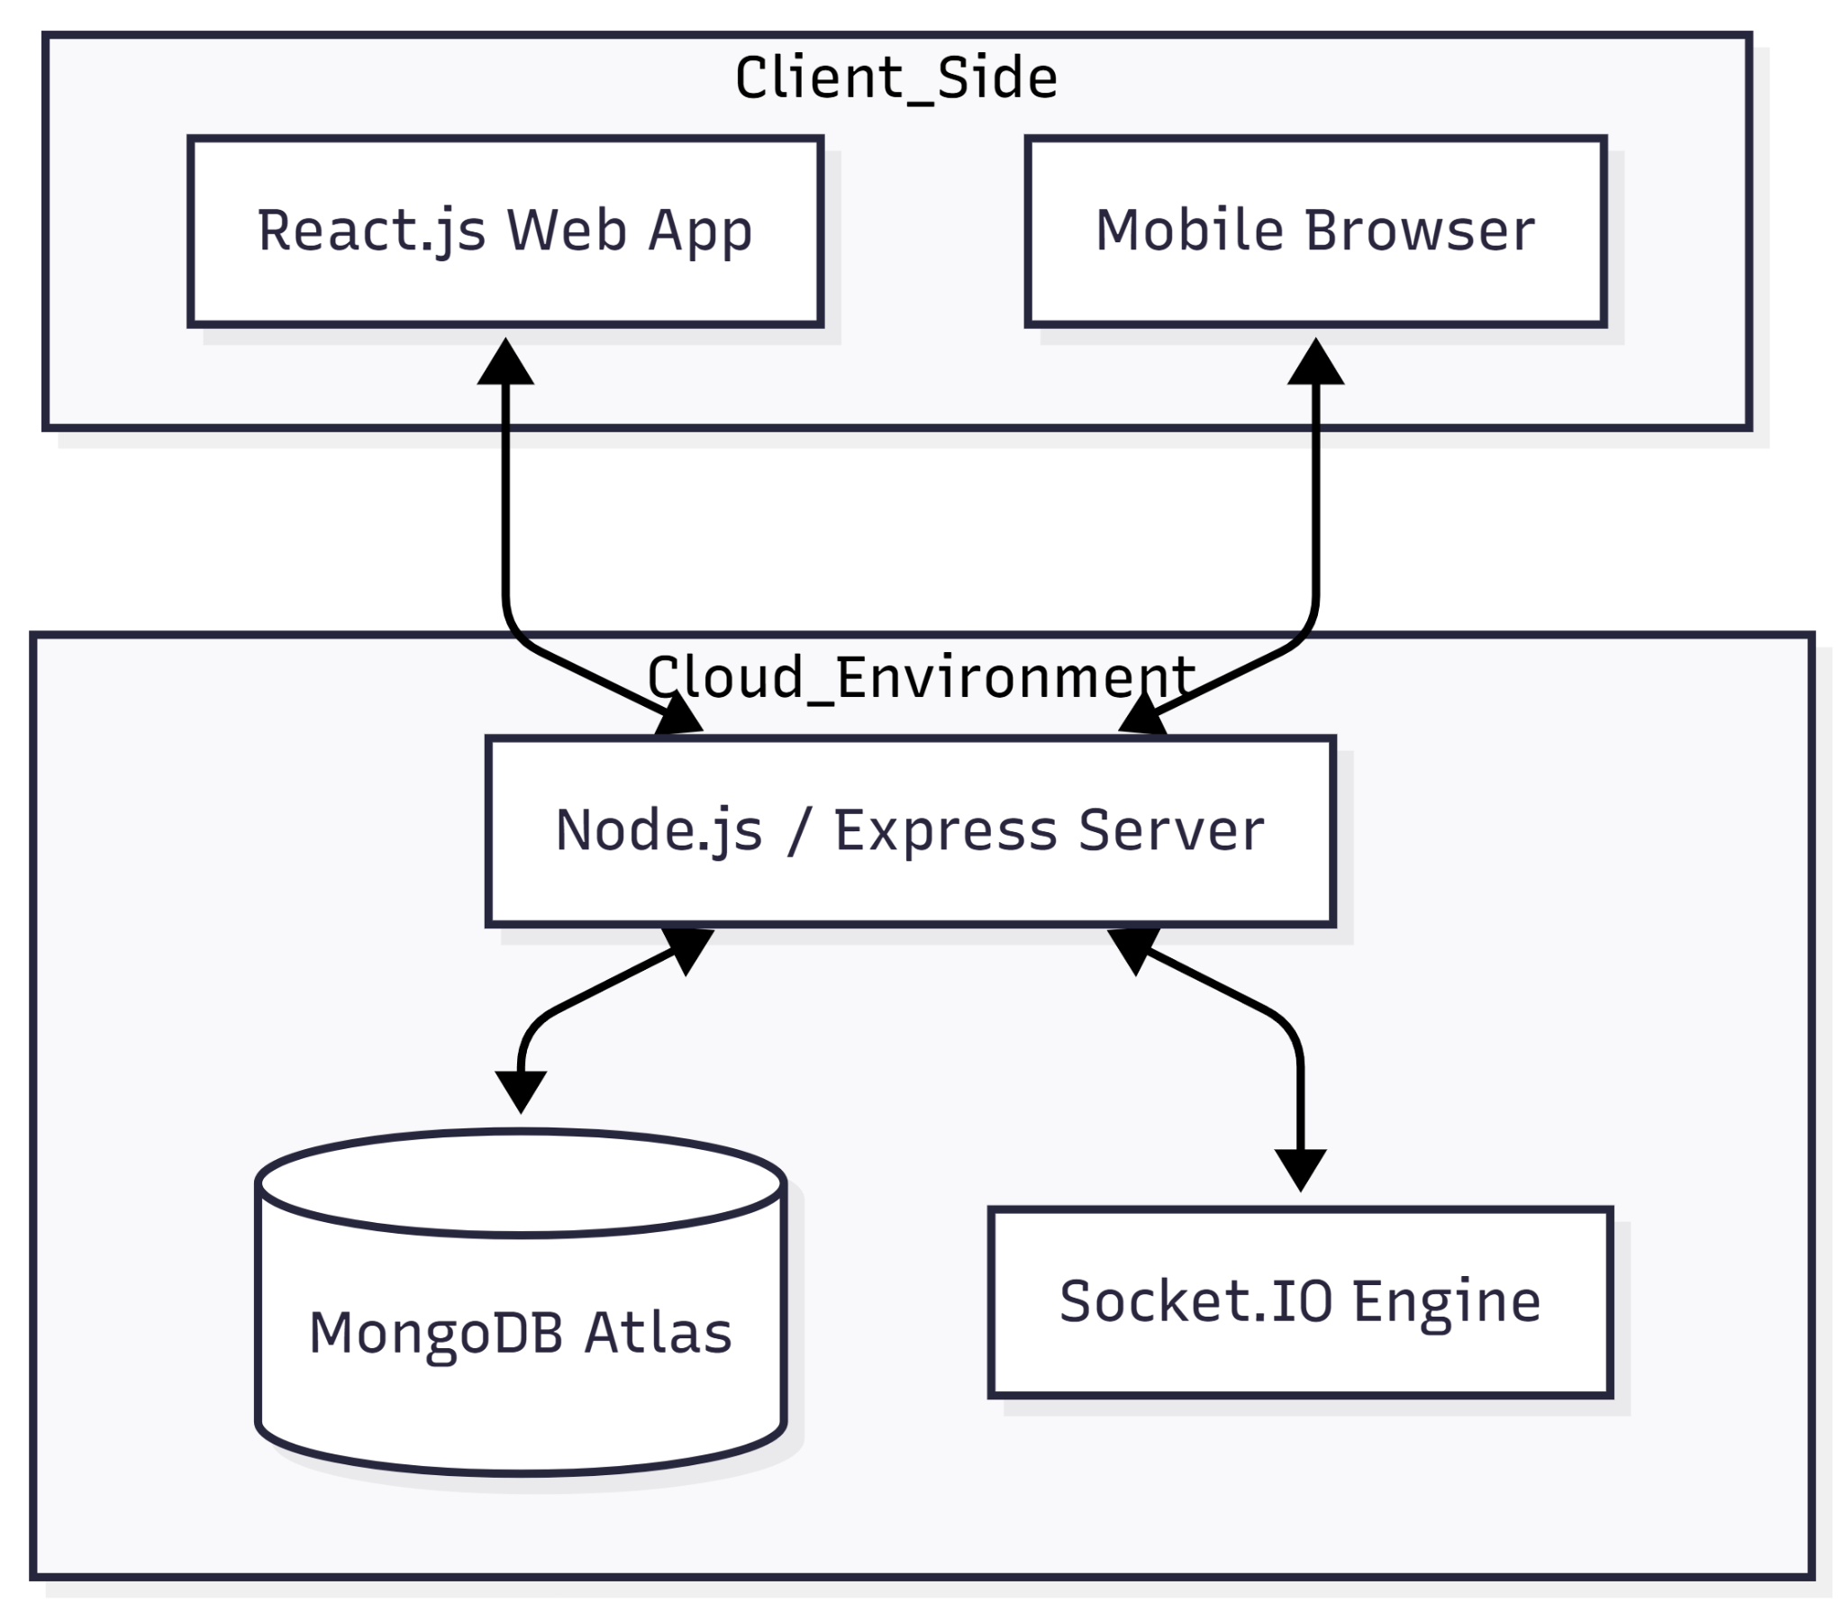
Figure 5.2: Deployment Architecture Diagram

Hosting Environment:
- Frontend: Hosted on Vercel or Netlify for high-availability React delivery.
- Backend: Deployed on a scalable cloud platform (e.g., Render, Heroku, or AWS).
- Database: MongoDB Atlas for managed, continuous data persistence and automated backups.

10. Conclusion & Future Scalability
The Hospital Smart Queue System provides a robust, real-time solution to the systemic inefficiencies of manual healthcare administration. By implementing a role-based MERN architecture supported by Socket.IO for low-latency updates and JWT for secure access, the system meets all core performance KPIs, including a target uptime of >= 99% and an average response time of <= 2 seconds.

10.1 Future Roadmap
The current modular design serves as a foundation for several high-impact scalability features:
- AI Queue Prediction: Utilizing the data collected in the Analytics Module to implement machine learning models that predict peak hours and suggest optimal staffing levels.
- EHR Integration: Connecting the Appointment Collection to Electronic Health Records (EHR) to allow doctors to view patient history directly from their dashboard.
- Telehealth Expansion: Integrating WebRTC or similar protocols into the Scheduling Module to allow for virtual consultations directly within the Patient and Doctor dashboards.

